D05 Datahub Data Mapping Specification – BlueYonder

Project: Data Enablement Stream
100999765

Origin/Author : Malek Aliouche

Approved by :

Date Approved:

Audience
Group / Team / Stakeholder | Focus Area
Project Technical Design Authority | By providing a detailed breakdown of the data fields required, this document will provide the TDA with a comprehensive understand of any required data flows and the required transformations. This will ensure the design adheres best practice and to the Imperial Brands architecture principles.
Engineering Team | Provide a detailed record as to what data is required from source systems to be imported into BlueYonder, including any data transformation services.
Testing Services | Help the team assess the testing scope, enabling them to produce relevant test cases and test scripts for integration testing.
Business Stakeholders | Provide an overview of the Data Landscape, to provide an understanding of how data will move through the system, which in turn will support decision-making and strategic planning

Document Control
This document will be owned and maintained by the groups and members listed below. All version management and future changes must involve the owners listed below.

This Document Version | 0.1
Author | Malek Aliouche
Date Issued

Amendment History

Version | Date Created | Created/  Amended By | Approved/  Reviewed by | Change Detail
0.1 | 27/07/2023 | Malek Aliouche | Giles Cuthbert  Oriol Cervantes-Grau  Adam Taylor  Yousif Houssain | Initial draft
1.1 | 31/01/2024 | Datahub Team | Sumanta Datta | Final Draft

Distribution

Recipient | Role
Remi Guillon | Project Sponsor
Erik Lenz | Head of Supply Chain Excellence
Jessica Bolte | Project Manager
Benjamin Bruhn | Head of Supply Chain Enablement
Maciej Grebski | Head of Demand Planning
Lesya Toryanyk | Demand Planning Transformation Manager
Jan Eismann | E2E SC Planning Solutions Manager
Marion Weber | Manager E2E Business Processes Master Data
Mohamed Khalifa | IT Business Partner
Steve Dickason | Head of Data Strategy, Governance & Architecture
Lalit Kapur | Data Project Manager
Patrice Gourlet | Head of Data Architecture
Javier Romero Blazquez | Head of Data Platforms
Sumanta Dutta | Data Architect

Document Sign-Off
Where relevant this document has been received and reviewed by the following people. Sign off via email to the solution architect indicates the document has been reviewed and the proposed solution is acceptable for the sections indicated.

Name | Role | Date received | Approving sections | Signoff
Maciej Grebski | Head of Demand Planning
Lesya Toryanyk | Demand Planning Transformation Manager
Jan Eismann | E2E SC Planning Solutions Manager
Marion Weber | Manager E2E Business Processes Master Data
Sumanta Dutta | Data Architect | 31-01-2024 | Approved | Sign off received
Lalit Kapur | Data Project Manager

Contents
Amendment History 2
Distribution 3
Document Sign-Off 3
1. Document Purpose 3
2. Data Model 5
3. Data Field Mapping Specifications 6
4. Data Issues Identified 8
5. Appendix 9
5.1. Glossary Of Terms 10

Document Purpose

This document serves as the data catalogue for the Blue Yonder Supply Chain Planning System. It details the comprehensive field-level mapping of data, as sourced from Imperial Data, that will be used to prepare the Demand Modules within Blue Yonder. The overarching aim of this data catalogue is to enable seamless data ingestion and ensure the accuracy and the reliability of the information feeding our Supply Chain Planning processes. This document should be reviewed in conjunction with other documents prepared, including D11 Data Mapping and Model Document, and D10 Solution Design document.
Within this catalogue, we provide specific data source descriptions, meticulous field-level mapping, and transformation logic as required. The data catalogue identifies incomplete mappings, enabling the Data Design Team to determine the subsequent actions required for resolution. The document is created with a consideration for data quality, governance rules, and future system enhancements to assure its longevity and practicality. In turn, this will foster an environment where informed decision-making is backed by robust and reliable data.
We believe this data catalogue will be an essential tool to support the Unify project in streamlining our supply chain planning operations and increase overall efficiency. It is designed for use by IT professionals involved in system maintenance and data handling, as well as non-technical staff who will be key users of the supply chain planning system.
In Scope for this data catalogue are mappings for 20 entities (+2 back up) as outlined in the SOW.

Data Model

The following diagram provides a high-level overview of the data flow for the Blue Yonder implementation within the Datahub:

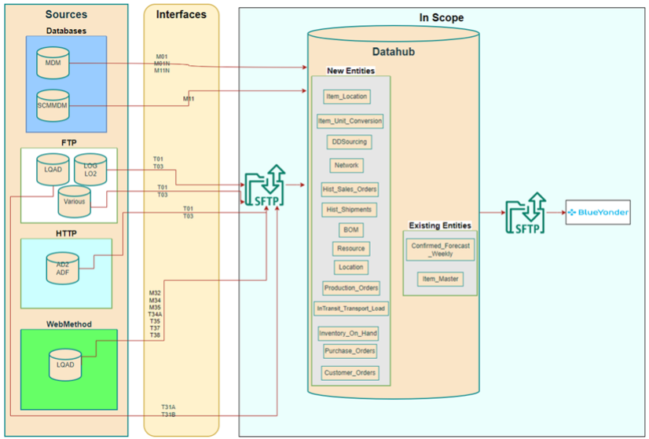

This diagram outlines the movement of data into and out of the Datahub, focusing on the data required for the Blue Yonder implementation. The data is sourced and made available to Datahub at a designated source SFTP location by the client. From there, Datahub initiates the process of pulling the data into its environment for further processing.

Within Datahub, various processes are executed to ensure the quality and readiness of the data for consumption. These processes include validation, cleansing, transformation, conformation, and loading of the data into Datahub. These steps are essential for ensuring data integrity, consistency, and compliance with the requirements of the Blue Yonder system.

Once the data has been processed within Datahub, it is exported and pushed to the target SFTP location. This enables the ingestion of the data into the Blue Yonder system, where it can be utilized for various purposes such as inventory management, demand forecasting, and supply chain optimization.

The E2E BY Data Catalogue tab provides more technical details relating to the individual interfaces and provides links to the target mapping documents.

Data Field Mapping Specifications

Below is a list of completed source-to-target data mappings. The existence of duplicate entity files is attributed to the receipt of multiple source data files from Imperial Brands, necessitating individual source-to-target mappings for each interface provided. The entirety of the essential mappings for this phase are referenced in the enclosed document: D05 - (transit state) Data Catalogue
- M32 - BOM
- T31B - CUSTOMERORDERS
- T38 - CUSTOMERORDERS
- DDSOURCING
- DH - FORECAST
- T01 - HIST_SALESORDER
- T01 - HIST_SHIPMENTS
- T03 - INTRANSIT (TRANSPORTLOAD)
- T35 - INTRANSIT (TRANSPORTLOAD)
- T03 - INVENTORYONHAND
- T35 - INVENTORYONHAND
- DH - ITEM
- M01 - ITEMLOCATION
- M01N - ITEMLOCATION
- M01 - ITEMUNITCONVERSION
- M01N - ITEMUNITCONVERSION
- M35 - LOCATION
- M11 - NETWORK
- T34B - PRODUCTIONORDER
- T37 - PURCHASEORDER
- T31A - PURCHASEORDER
- M34 - RESOURCE

Legacy Data Remediation

During the process of Data Profiling, we discovered multiple issues with the data received via the Web Method interfaces that are currently utilized by Imperial Brands. Consequently, it is crucial to assess the following suggestions to guarantee optimal efficiency in the planned works.
- Imperial Brands need to support the Data Design Team to improve the existing interfaces to add missing data fields and consider creating new interfaces to provide the missing data.
- Imperial Brands could provide the Data Design Team with an alternative data format (XML) to provide more than single entries.
- Imperial Brands could identify a Data Owner who can be contacted to provide data files with improved data quality.
- Imperial Brands need to provide the Data Design Team with alternative ways to obtain data from systems, for example pulling data directly from the source rather than the current method via the existing WebMethods interface.

Appendix

Glossary Of Terms

The table below describes generally used data terminology and terms specific to this project.
Term | Definition
ACID | Atomicity, Consistency, Isolation, and Duration
AI | Artificial Intelligence
BI | Business Intelligence
CSV | Comma-Separated Values
DB | Database
DBMS | Database Management System
DDL | Data Definition Language
Delta | New data that has been added to a table since the last load
Data Hub | Imperial Brands Data Platform leveraged to support Demand Planning
DML | Data Manipulation Language
DM | Data Mart
DQ | Data Quality
DW | Data Warehouse
EDW | Enterprise Data Warehouse
ELT | Extract, Load and Transform
ERD | Entity Relationship Diagram
ETL | Extract, Transform and Load
FK | Foreign Key
GDPR | General Data Protection Regulation
JSON | JavaScript Object Notation
KPI | Key Performance Indicator
LOB | Line of Business
MDM | Master Data Management
ML | Machine Learning
MOLAP | Multi-dimensional Online Analytical Processing
ODBC | Open Database Connectivity
ODS | Operational Data Store
OLE DB | Object Linking and Embedding Database
OLTP | Online Transactional Processing
PBI | Power BI
PK | Primary Key
RDBMS | Relational Database Management System
ROLAP | Relational Online Analytical Processing
SCD | Slowly Changing Dimension
Snapshot | Point-in-time copy of a dataset
SQL | Structured Query Language

